Cemetery Maintenance Class
Saturday, April 30, 2022

The Henderson County Cemetery Advisory Committee will host a cemetery maintenance training for all interested persons Saturday, April 30, 2022, at the William Capps, aka Fortune-Kuykendall, Cemetery on Fortune Place Road in the Greenbriar Subdivision off U.S. 176 in the Zirconia - Green River area. Registration is requested. Class size is limited, so register soon.

Due to limited parking at the cemetery, plan to meet at 9:30 a.m. to carpool from the Ingles store at the corner of the Spartanburg Highway (U.S. 176) and Highland Lake Road, behind the car wash near the National Guard Armory.

Hands-on training on the cleaning and leveling of gravestones will begin at 10 a.m. Warren Scott, gravestone conservator, will teach the proper and careful methods to preserve gravestones.

To register for the class or for more information, contact:
Toby Linville at 694-6627 or tlinville@hendersoncountync.gov

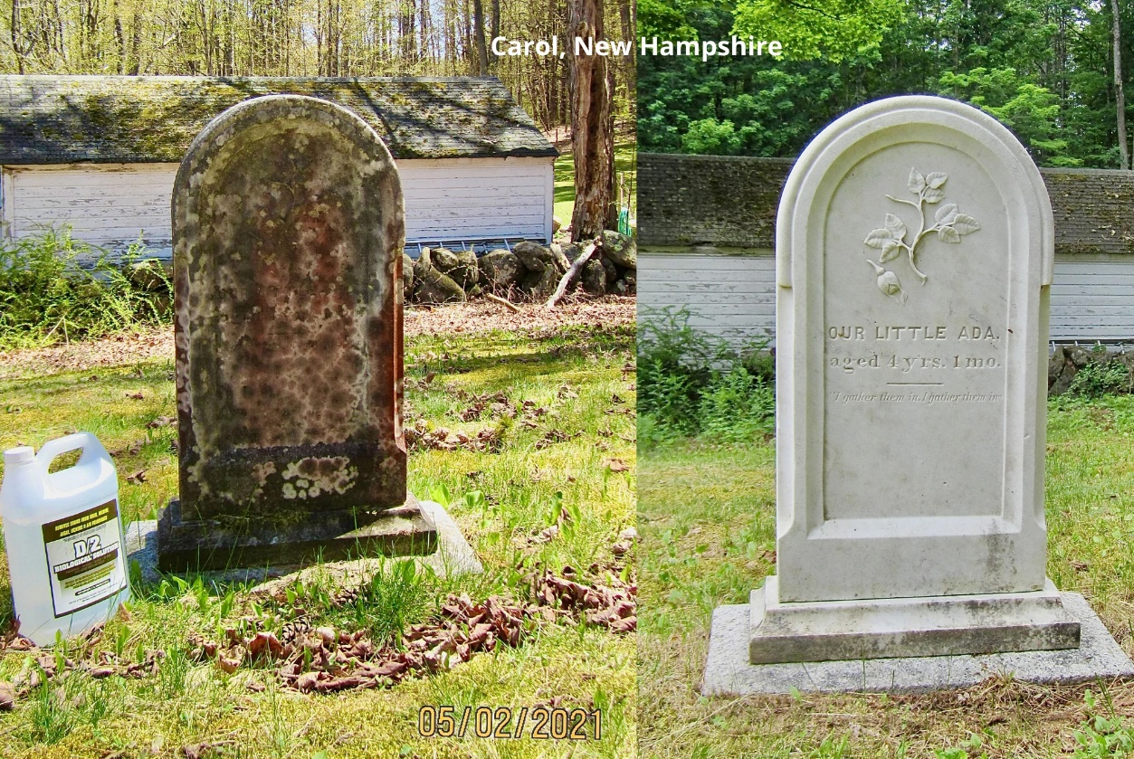

Photo courtesy of Atlas Preservation, Southington, Connecticut - https://atlaspreservation.com

